RECEIVING
- Expiration Date: Create a ticket with TaskletFactory. Issue when someone manually enters an expiration date.
- Lot Number Format: Fix the calculated value. In the sample below, the item has an expiration of 36M. If the expiration date is 10/31/2028, the system should have assigned the lot number as RB20251031. Instead, it used today’s date (0605) for the month and day.
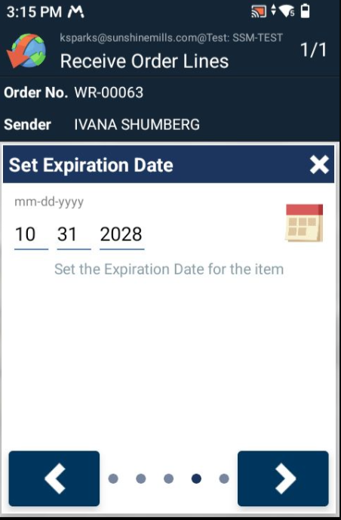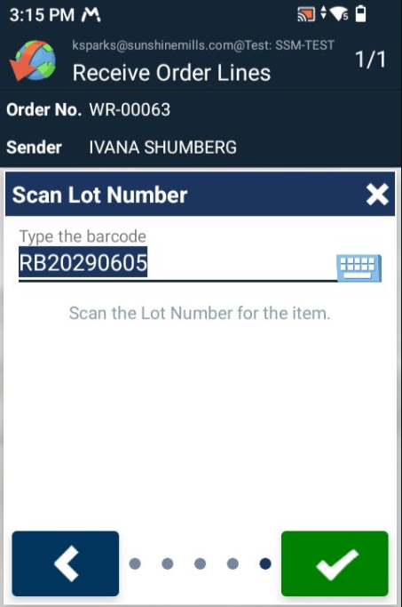

PICK
- Lot Status: When scanning a non-compliance lot, eliminate any technical notes.
BNN> This is not possible right now. It is something BC adds on when throwing the error.
- Quantity: Make the value view only. The SSM team always builds the license plates before picking.
- Pick from LP: Don’t allow picking the same LP twice. Display a message before registering the pick.
BNN> The fix I created didn’t work correctly due to a misunderstanding of the flow. I have checked up on this and will fix it in a different way. It is more time consuming and will first be in next push.
- Lice Plate Bin: After registering the pick, the bin should reflect the “Take-To” bin (Ship) to align with the actual inventory.
BNN> When posting the pick the bin will be changed to “Ship”.
If the LP is not loaded, it will need to be moved to stock.
BNN> when in the flow should this happen?
- Display an error when selecting an incorrect pallet type. The header changed colors to red, but a message is needed. Make sure to return to the main page.
BNN> I tested this and are getting this message. If it is still a problem please find the error in the Mobile Document Queue and send me the response for the error.
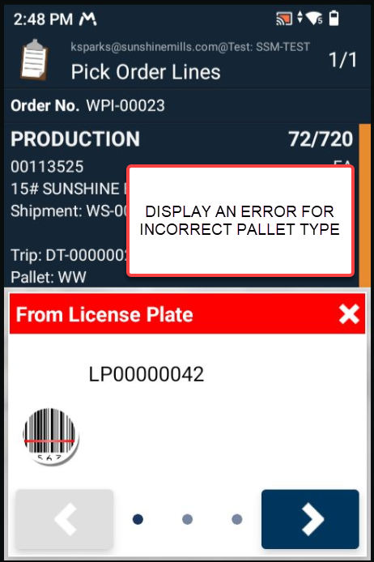 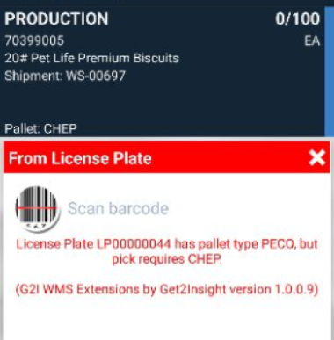
- Don’t split license plates. Per the previous note, the SSM team will always prebuild the LP with the correct context (good or bad). In our example, the sales order requires 500 units. The LP had 600 units. The system created a new LP for the picked quantity and left the remaining inventory of 100 on the old LP. If the quantity on the LP exceeds the pick quantity, display an error.

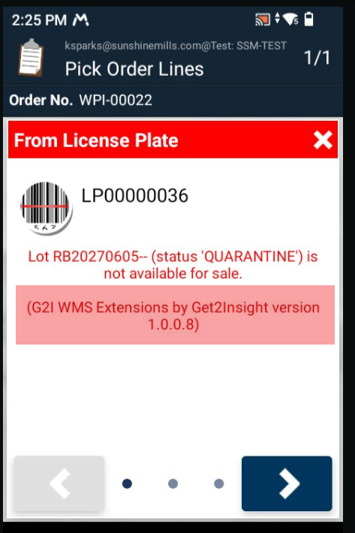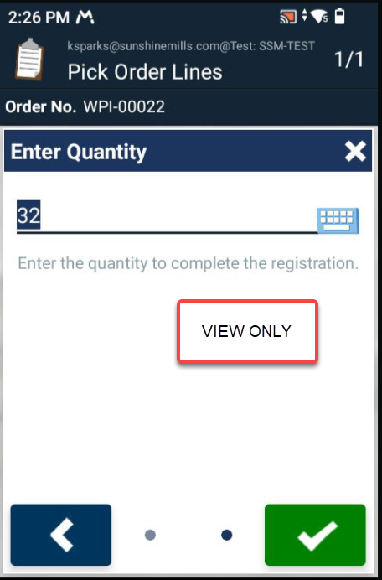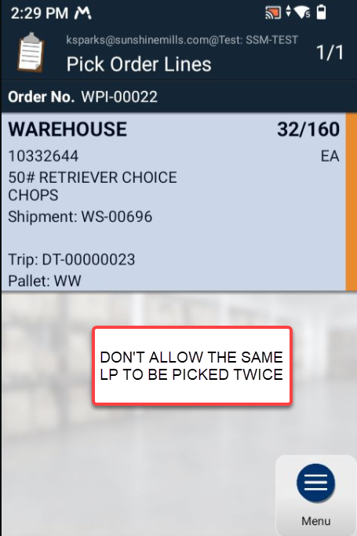
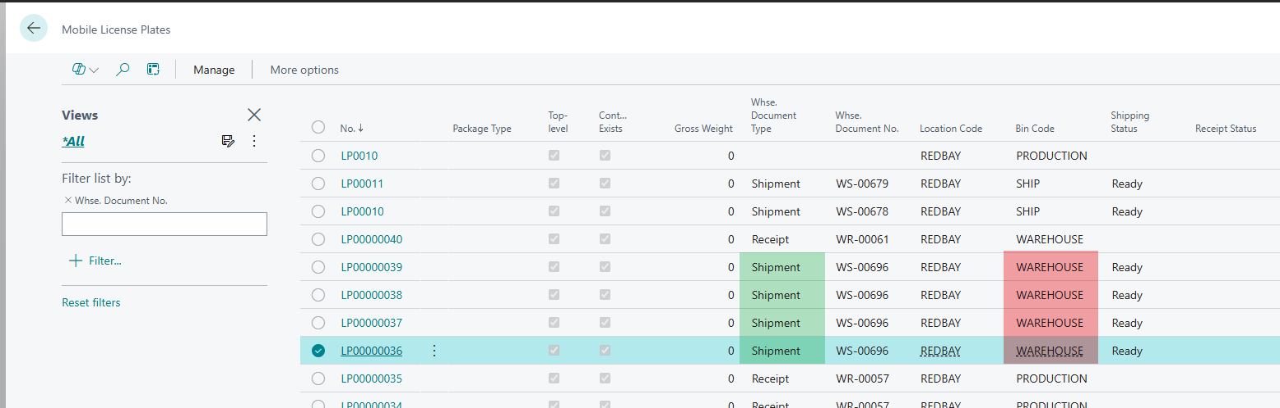

LICENSE PLATE
- Fix the flow of changing the pallet type. In our example, we selected Redbay, clicked on Change Pallet Type, and had to re-enter Redbay. The system should remember the previous selection.
- Eliminate the License Plate Details page.
- Swap the Content icon with the Unplanned Move since it will be used the most.
BNN> The Honeywell scanner can show 4 promoted items… but it seems like the Zebra only have room for three. So I swapped the menu items.
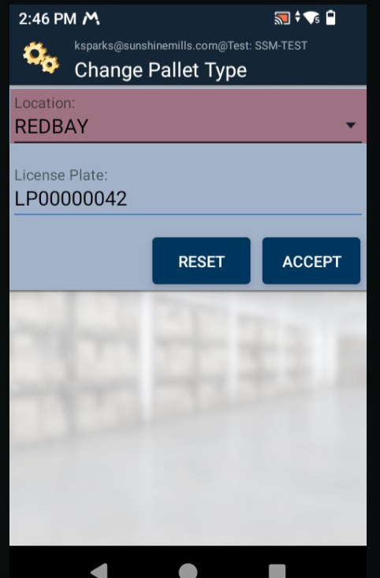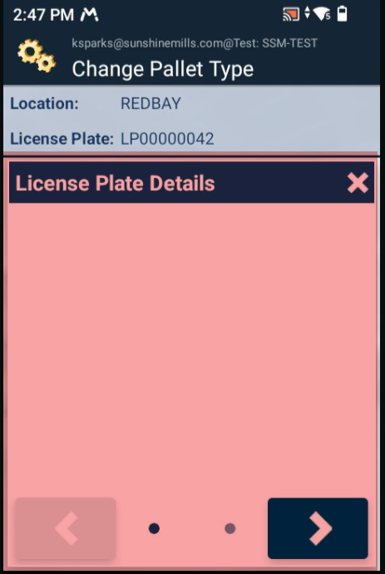

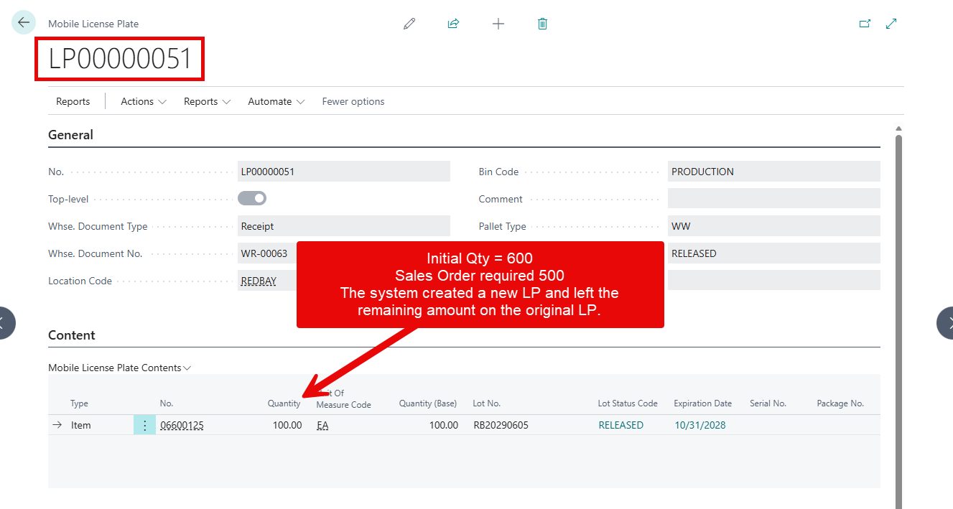
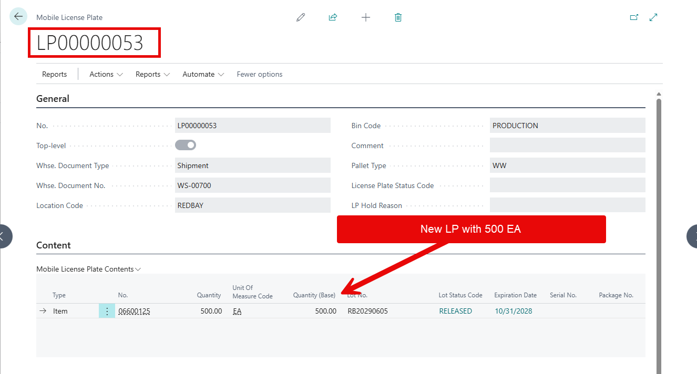
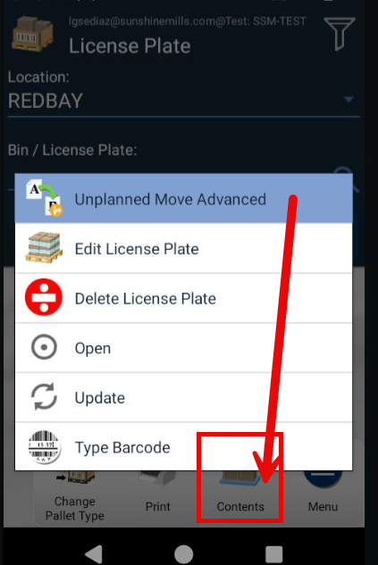

MENU
- Eliminate these two options
